**SPFx – React with Router**

**Create a new SPFx web part project**

* Navigate to your favourite folder
* create new folder
* move to newly created folder
* Open Command prompt and run following comment to create a new web part by running the Yeoman SharePoint Generator
  + - yo @microsoft/sharepoint
* When prompted:
* Enter the webpart name as your solution name, and then select Enter.

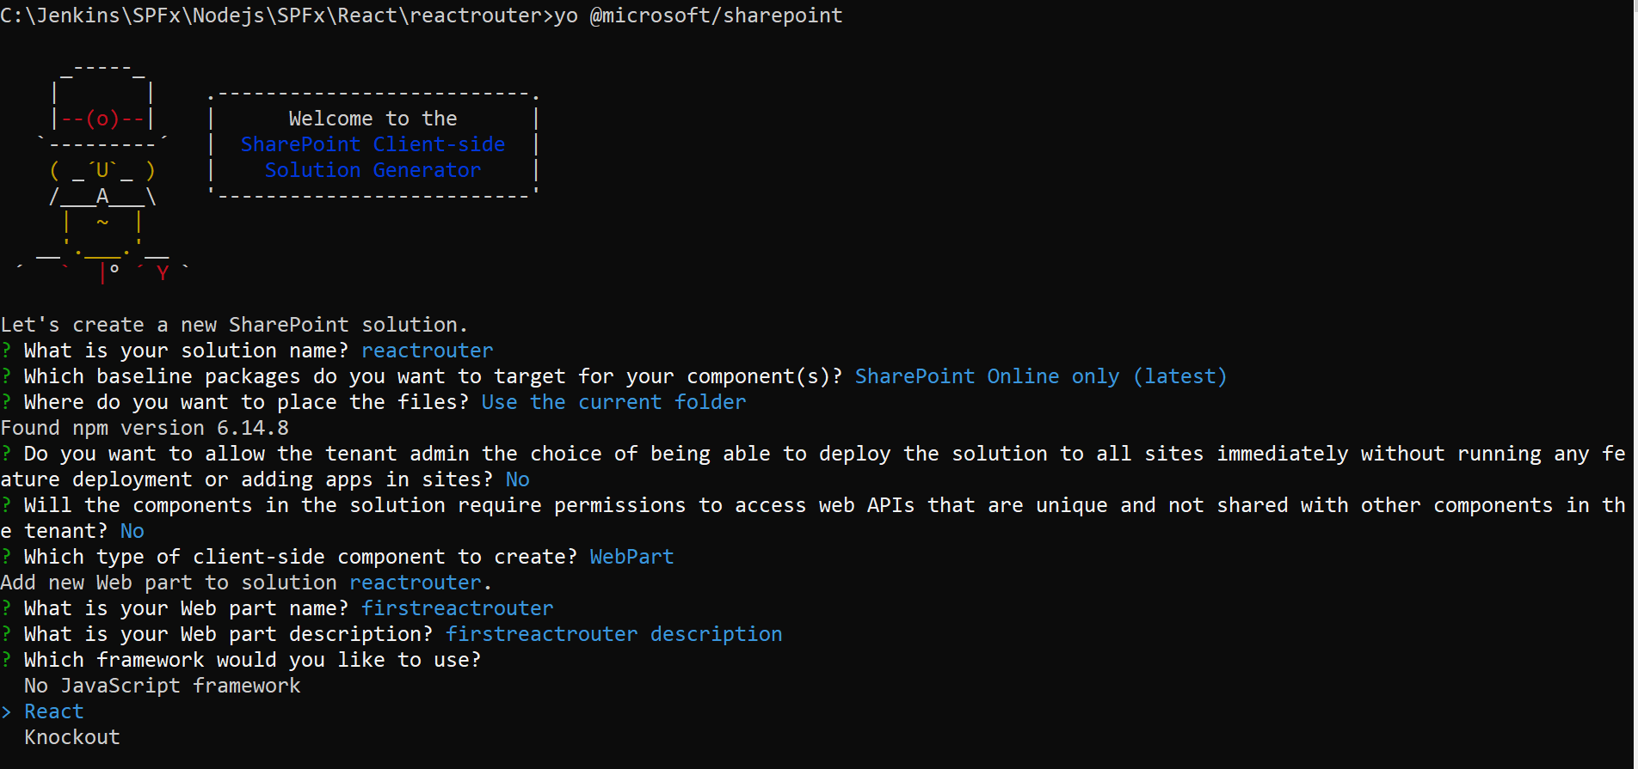

Install the library and required dependencies

npm install react-router-dom --save

Open visual studio

Go to Root component file ./src/webparts/firstreactrouter/components/ Firstreactrouter.tsx

import { HashRouter, Route } from "react-router-dom";

import { Nav, INavStyles, INavLinkGroup } from 'office-ui-fabric-react/lib/Nav';

import { Stack, IStackTokens } from 'office-ui-fabric-react/lib/Stack';

Define the navigation

const navStyles: Partial<INavStyles> = { root: { width: 300 } };

const stackTokens: IStackTokens = { childrenGap: 40 };

const navLinkGroups: INavLinkGroup[] = [

  {

    name: 'React Components',

    links: [

      {

        key: 'Customers',

        name: 'Customers',

        url: '#/',

      },

      {

        key: 'CustomerDetails',

        name: 'Customer Details',

        url: '#/Customer/153',

      },

      {

        key: 'Customerfiles',

        name: 'Customer files',

        url: '#/CustomerFiles',

      },

      {

        key: 'About',

        name: 'About us',

        url: '#/about',

      }

    ],

  }

];

Replace return render method in firstreactrouter class

<div className={styles.firstreactrouter}>

        <Stack horizontal tokens={stackTokens}>

          <Nav styles={navStyles} ariaLabel="Navigation" groups={navLinkGroups} />

          <HashRouter>

            <Route path="/" exact component={SpfxCustomers}></Route>

            <Route path="/Customer/:id" component={SpfxCustomerDetails}></Route>

            <Route path="/CustomerFiles/" component={SpfxCustomersFiles}></Route>

            <Route path="/about" component={Spfxabout}></Route>

          </HashRouter>

        </Stack>

      </div>

Create three components

1. Customer details

import * as React from 'react';

import styles from './Firstreactrouter.module.scss';

import { IFirstreactrouterProps } from './IFirstreactrouterProps';

export default class SpfxCustomerDetails extends React.Component<IFirstreactrouterProps, {}> {

public render(): React.ReactElement<IFirstreactrouterProps> {

return (

<div className={styles.firstreactrouter}>

<h1>Selected Customer Id is <span style={{color:'green'}}>{this.props["match"]["params"]["id"]}</span></h1>

</div>

);

}

}

1. Customers

import * as React from 'react';

import styles from './Firstreactrouter.module.scss';

import { IFirstreactrouterProps } from './IFirstreactrouterProps';

export default class SpfxCustomers extends React.Component<IFirstreactrouterProps, {}> {

  public render(): React.ReactElement<IFirstreactrouterProps> {

    return (

      <div className={ styles.firstreactrouter }>

          <h1>Customers Component</h1>

          <h1><a href="#/Customer/153">Customer 153</a></h1>

          <h1><a href="#/Customer/154">Customer 154</a></h1>

          <h1><a href="#/Customer/155">Customer 155</a></h1>

          <h1><a href="#/Customer/156">Customer 156</a></h1>

      </div>

    );

  }

}

1. Customer files

import * as React from 'react';

import styles from './Firstreactrouter.module.scss';

import { IFirstreactrouterProps } from './IFirstreactrouterProps';

export default class SpfxCustomersFiles extends React.Component<IFirstreactrouterProps, {}> {

  public render(): React.ReactElement<IFirstreactrouterProps> {

    return (

      <div className={styles.firstreactrouter}>

        <h1>Files Component</h1>

      </div>

    );

  }

}

1. About us

import * as React from 'react';

import styles from './Firstreactrouter.module.scss';

import { IFirstreactrouterProps } from './IFirstreactrouterProps';

export default class Spfxabout extends React.Component<IFirstreactrouterProps, {}> {

  public render(): React.ReactElement<IFirstreactrouterProps> {

    return (

      <div className={styles.firstreactrouter}>

        <h1>ABOUT US</h1>

        We Launched by the middle of the year 2019 with a team of five to provide a world class cloud based services to the customers with a very economical prices.Yes, we are a cloud based application services company incubated by few IT techies who had a dream to lead a company that provides end to end cloud based solutions to the customers.

      </div>

    );

  }

}

Import other components in root firstreactrouter.tsx file

import SpfxCustomersFiles from './SpfxCustomersFiles';

import SpfxCustomers from './SpfxCustomers';

import SpfxCustomerDetails from './SpfxCustomerDetails';

import Spfxabout from './Spfxabout';

Test it

Gulp serve